**BrowserMonkey**



**Testing**

v 1.0

**Software House One**

**Version History**

Document name: QA Team/scratch/Testing.docx

Document version: 1.0

Document author: Paul Calcraft 2009/05/30

Document author: Elpida Kyriakou 2009/06/02

Document author: Ioanna Kyprianou 2009/06/03  
Document author: Irene Schiza 2009/06/05

Document author: Sohani Amiruzzaman 2009/06/06

Document auditor: Ioanna Kyprianou 2009/06/08

Document auditor: Daniel Cooper 2009/06/08

Document auditor: Paul Calcraft 2009/06/08

Document auditor: Sohani Amiruzzaman 2009/06/08

**Table of Contents**

1 Introduction 4

3 Requirement 3 – Conformance 5

3.2 Invalid tag format 5

3.3 Empty tags 5

3.4 Unrecognised tags 5

3.5 Recognised non-implemented tags 5

3.6 General structure tags 5

3.7 Recognised supported tags 6

3.8 Font tag attributes 8

3.9 Nesting and Order 8

3.10 Content Model 8

4 Requirement 4 – Tags 9

4.1 Blank lines 9

4.2 Heading 10

4.3 Paragraph 11

4.4 Unordered List 12

4.5 Ordered List 13

4.6 Definition List 14

4.7 Blockquote 15

4.8 Centred Text 16

4.9 Pre-formatted Text 17

4.10 Horizontal Rule 18

4.11 Italics 19

4.12 Bold 20

4.13 Teletype 21

4.14 Underline 22

4.15 Font 23

5 Requirements 5 – Tables 24

6 Requirement 6 – Links 25

7 Requirement 7 – Search 26

8 Requirement 8 – Zoom 29

# Introduction

We received feedback when giving in our (300 page) acceptance criteria document that our tests were more extensive than they needed to be. For this reason, combined with time and printing constraints, we have not documented every test with a screenshot. Instead, for each testing section we have a table showing the individual tests, and only for whole testing sections do we show a selection of screenshots. Most sections need only one screenshot example as the tests are very similar within each section.

The programmers have annotated any fails with explanations.

The numbering of the document matches the numbering of the acceptance criteria, which is why we go to heading 3 after this introduction.

# Requirement 3 – Conformance

## Invalid tag format

|  |  |  |  |  |
| --- | --- | --- | --- | --- |
| **Tests Id** | **Tested by** | **Most Recent Test** | **Pass/Fail** | **Details** |
| acc3-2-0001 | Ioanna Kyprianou | 05/06/2009 | Pass |  |
| acc3-2-0002 | Ioanna Kyprianou | 05/06/2009 | Pass |  |
| acc3-2-0003 | Ioanna Kyprianou | 05/06/2009 | Pass |  |

## Empty tags

|  |  |  |  |  |
| --- | --- | --- | --- | --- |
| **Tests Id** | **Tested by** | **Most Recent Test** | **Pass/Fail** | **Details** |
| acc3-2-0001 | Ioanna Kyprianou | 05/06/2009 | Pass |  |

## Unrecognised tags

|  |  |  |  |  |
| --- | --- | --- | --- | --- |
| **Tests Id** | **Tested by** | **Most Recent Test** | **Pass/Fail** | **Details** |
| acc3-4-0001 | Ioanna Kyprianou | 05/06/2009 | Fail |  |

*Programming Notes:*

We decided not to throw an error when a tag was found that was not recognised; we just render the contents of its tag.

## Recognised non-implemented tags

|  |  |  |  |  |
| --- | --- | --- | --- | --- |
| **Tests Id** | **Tested by** | **Most Recent Test** | **Pass/Fail** | **Details** |
| acc3-5-0001 | Ioanna Kyprianou | 05/06/2009 | Fail |  |

*Programming Notes:*

We did not have time to implement a way to store and retrieve every tag type in the full HTML specification that we have not implemented a renderer for.

## General structure tags

|  |  |  |  |  |
| --- | --- | --- | --- | --- |
| **Tests Id** | **Tested by** | **Most Recent Test** | **Pass/Fail** | **Details** |
| acc3-6-0001 | Ioanna Kyprianou | 05/06/2009 | Pass |  |
| acc3-6-0002 | Ioanna Kyprianou | 05/06/2009 | Pass |  |
| acc3-6-0003 | Ioanna Kyprianou | 05/06/2009 | Pass |  |
| acc3-6-0004 | Ioanna Kyprianou | 05/06/2009 | Pass |  |
| acc3-6-0005 | Ioanna Kyprianou | 05/06/2009 | Pass |  |
| acc3-6-0006 | Ioanna Kyprianou | 05/06/2009 | Pass |  |
| acc3-6-0007 | Ioanna Kyprianou | 05/06/2009 | Pass |  |
| acc3-6-0008 | Ioanna Kyprianou | 05/06/2009 | Pass |  |
| acc3-6-0009 | Ioanna Kyprianou | 05/06/2009 | Pass |  |
| acc3-6-00010 | Ioanna Kyprianou | 05/06/2009 | Pass |  |
| acc3-6-00011 | Ioanna Kyprianou | 05/06/2009 | Pass |  |

## Recognised supported tags

|  |  |  |  |  |
| --- | --- | --- | --- | --- |
| **Tests Id** | **Tested by** | **Most Recent Test** | **Pass/Fail** | **Details** |
| acc3-7-0001 | Ioanna Kyprianou | 05/06/2009 | Pass |  |
| acc3-7-0002 | Ioanna Kyprianou | 05/06/2009 | Pass |  |
| acc3-7-0003 | Ioanna Kyprianou | 05/06/2009 | Fail |  |
| acc3-7-0004 | Ioanna Kyprianou | 05/06/2009 | Pass |  |
| acc3-7-0005 | Ioanna Kyprianou | 05/06/2009 | Fail |  |
| acc3-7-0006 | Ioanna Kyprianou | 05/06/2009 | Fail |  |
| acc3-7-0007 | Ioanna Kyprianou | 05/06/2009 | Fail |  |
| acc3-7-0008 | Ioanna Kyprianou | 05/06/2009 | Pass |  |
| acc3-7-0009 | Ioanna Kyprianou | 05/06/2009 | Pass |  |

*Programming Notes:*

The acceptance criteria was too ambitious here, the sort of correction required to pass some of these tests was too advanced for this project.

Screen shot

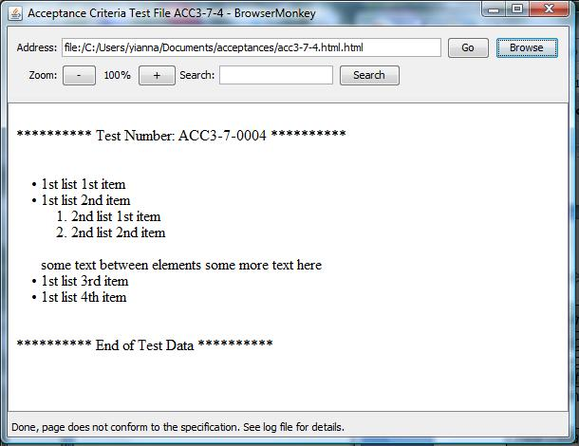

Log File

05-Jun-2009 19:27:55 browsermonkey.utility.BrowserMonkeyLogger status

INFO: Loading file:/C:/Users/yianna/Documents/acceptances/acc3-7-4.html.html

05-Jun-2009 19:27:55 browsermonkey.utility.BrowserMonkeyLogger conformance

WARNING: List Error: shorthand list notation - closing <li>.

05-Jun-2009 19:27:55 browsermonkey.utility.BrowserMonkeyLogger conformance

WARNING: List Error: shorthand list notation - closing <li>.

05-Jun-2009 19:27:55 browsermonkey.utility.BrowserMonkeyLogger status

INFO: Done, page does not conform to the specification. See log file for details.

## Font tag attributes

|  |  |  |  |  |
| --- | --- | --- | --- | --- |
| **Tests Id** | **Tested by** | **Most Recent Test** | **Pass/Fail** | **Details** |
| acc3-8-0001 | Irene Schiza | 05/06/2009 | Pass |  |
| acc3-8-0002 | Irene Schiza | 05/06/2009 | Pass |  |
| acc3-8-0003 | Irene Schiza | 05/06/2009 | Pass |  |
| acc3-8-0004 | Irene Schiza | 05/06/2009 | Fail |  |
| acc3-8-0005 | Irene Schiza | 05/06/2009 | Pass |  |
| acc3-8-0006 | Irene Schiza | 05/06/2009 | Pass |  |
| acc3-8-0007 | Irene Schiza | 05/06/2009 | Pass |  |
| acc3-8-0008 | Irene Schiza | 05/06/2009 | Fail |  |
| acc3-8-0009 | Irene Schiza | 05/06/2009 | Fail |  |
| acc3-8-0010 | Irene Schiza | 05/06/2009 | Pass |  |
| acc3-8-0011 | Irene Schiza | 05/06/2009 | Fail |  |
| acc3-8-0012 | Irene Schiza | 05/06/2009 | Pass |  |

*Programming Notes:*

The acceptance criteria was incorrect here, expecting the renderer to correct spaces inside tag types and similar problems, but even full browsers do not support such correction.

## Nesting and Order

|  |  |  |  |  |
| --- | --- | --- | --- | --- |
| **Tests Id** | **Tested by** | **Most Recent Test** | **Pass/Fail** | **Details** |
| acc3-9-0001 | Irene Schiza | 05/06/2009 | Pass |  |
| acc3-9-0002 | Irene Schiza | 05/06/2009 | Fail |  |
| acc3-9-0003 | Irene Schiza | 05/06/2009 | Pass |  |
| acc3-9-0004 | Irene Schiza | 05/06/2009 | Fail |  |
| acc3-9-0005 | Irene Schiza | 05/06/2009 | Fail |  |
| acc3-9-0006 | Irene Schiza | 05/06/2009 | Fail |  |

*Programming Notes:*

The acceptance criteria was too ambitious again here, the sort of correction required to pass some of these tests was too advanced for this project.

## Content Model

Test failed.

|  |  |  |  |  |
| --- | --- | --- | --- | --- |
| **Tests Id** | **Tested by** | **Most Recent Test** | **Pass/Fail** | **Details** |
| acc3-10-0001 | Irene Schiza | 05/06/2009 | Fail |  |

*Programming Notes:*

We did not have time to implement this aspect of conformance testing, it would have required a fairly full specification of HTML including distinguishing between block and inline elements.

# Requirement 4 – Tags

## Blank lines

|  |  |  |  |  |
| --- | --- | --- | --- | --- |
| test id | **Tested by** | **Most Recent Test** | **Pass/Fail** | **Details** |
| acc4-1-0001 | Sohani Amiruzzaman | 05/06/2009 | Pass |  |

Screenshot

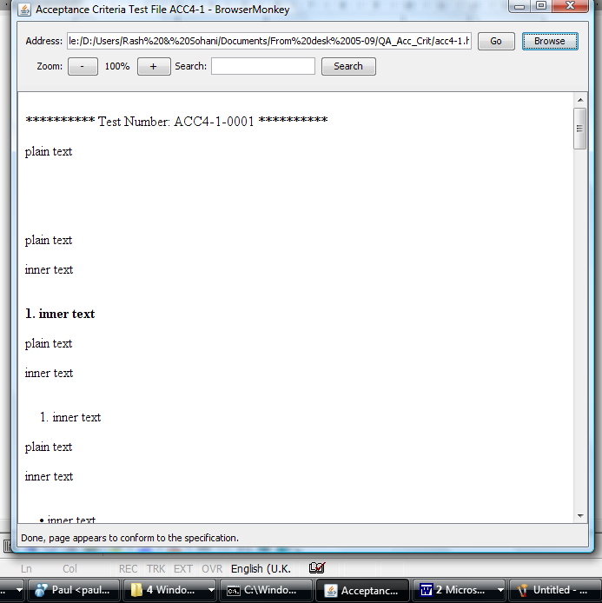

## Heading

|  |  |  |  |  |
| --- | --- | --- | --- | --- |
| **Test id** | **Tested by** | **Most recent test** | **Pass/fail** | **Details** |
| acc4-2-0001 | Sohani Amiruzzaman | 05/06/2009 | pass |  |
| acc4-2-0002 | Sohani Amiruzzaman | 05/06/2009 | pass |  |
| acc4-2-0003 | Sohani Amiruzzaman | 05/06/2009 | pass |  |
| acc4-2-0004 | Sohani Amiruzzaman | 05/06/2009 | pass |  |
| acc4-2-0005 | Sohani Amiruzzaman | 05/06/2009 | pass |  |
| acc4-2-0006 | Sohani Amiruzzaman | 05/06/2009 | pass |  |
| acc4-2-0007 | Sohani Amiruzzaman | 05/06/2009 | pass |  |
| acc4-2-0008 | Sohani Amiruzzaman | 05/06/2009 | pass |  |

Screenshot

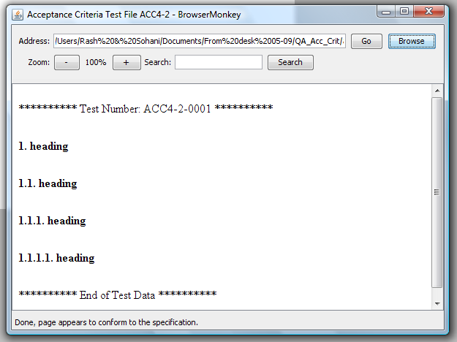

## Paragraph

|  |  |  |  |  |
| --- | --- | --- | --- | --- |
| **Test id** | **Tested by** | **Most recent test** | **Pass/fail** | **Details** |
| acc4-3-0001 | Sohani Amiruzzaman | 05/06/2009 | pass |  |
| acc4-3-0002 | Sohani Amiruzzaman | 05/06/2009 | pass |  |
| acc4-3-0003 | Sohani Amiruzzaman | 05/06/2009 | pass |  |

Screenshot

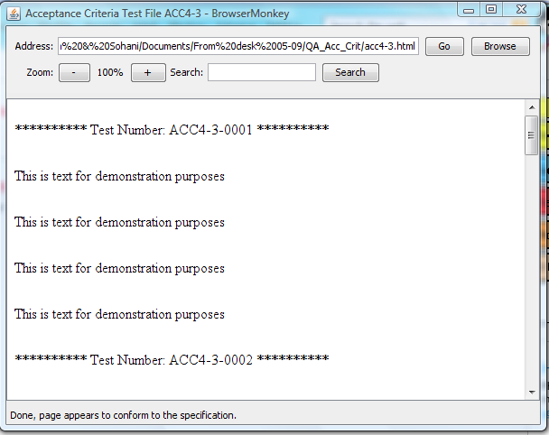

## Unordered List

.

|  |  |  |  |  |
| --- | --- | --- | --- | --- |
| **Test id** | **Tested by** | **Most recent test** | **Pass/fail** | **Details** |
| acc4-4-0002 | Sohani Amiruzzaman | 05/06/2009 | pass |  |
| acc4-4-0003 | Sohani Amiruzzaman | 05/06/2009 | pass |  |
| acc4-4-0004 | Sohani Amiruzzaman | 05/06/2009 | pass |  |
| acc4-4-0005 | Sohani Amiruzzaman | 05/06/2009 | pass |  |
| acc4-4-0006 | Sohani Amiruzzaman | 05/06/2009 | pass |  |
| acc4-4-0007 | Sohani Amiruzzaman | 05/06/2009 | pass |  |
| acc4-4-0008 | Sohani Amiruzzaman | 05/06/2009 | pass |  |
| acc4-4-0009 | Sohani Amiruzzaman | 05/06/2009 | pass |  |
| acc4-4-0010 | Sohani Amiruzzaman | 05/06/2009 | pass |  |

Screenshot

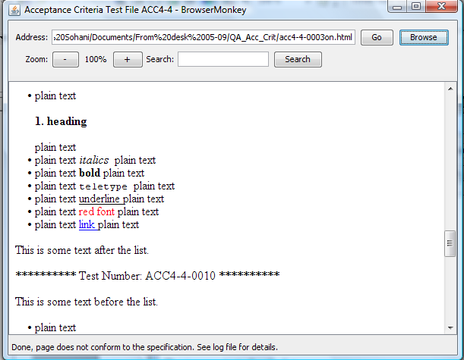

## Ordered List

|  |  |  |  |  |
| --- | --- | --- | --- | --- |
| **Test id** | **Tested by** | **Most recent test** | **Pass/fail** | **Details** |
| acc4-5-0001 | Sohani Amiruzzaman | 05/06/2009 | pass |  |
| acc4-5-0002 | Sohani Amiruzzaman | 05/06/2009 | pass |  |
| acc4-5-0003 | Sohani Amiruzzaman | 05/06/2009 | pass |  |
| acc4-5-0004 | Sohani Amiruzzaman | 05/06/2009 | pass |  |
| acc4-5-0005 | Sohani Amiruzzaman | 05/06/2009 | pass |  |
| acc4-5-0006 | Sohani Amiruzzaman | 05/06/2009 | pass |  |
| acc4-5-0007 | Sohani Amiruzzaman | 05/06/2009 | pass |  |
| acc4-5-0008 | Sohani Amiruzzaman | 05/06/2009 | pass |  |
| acc4-5-0009 | Sohani Amiruzzaman | 05/06/2009 | pass |  |
| acc4-5-0010 | Sohani Amiruzzaman | 05/06/2009 | pass |  |

Screenshot

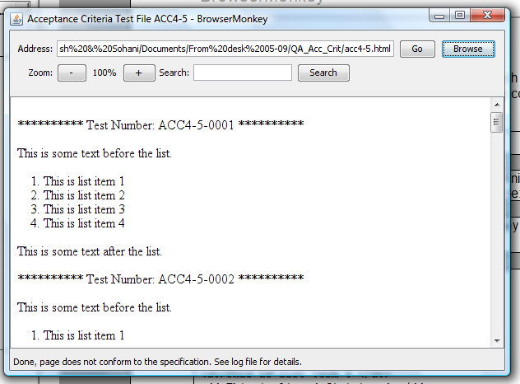

## Definition List

.

|  |  |  |  |  |
| --- | --- | --- | --- | --- |
| **Test id** | **Tested by** | **Most recent test** | **Pass/fail** | **Details** |
| acc4-6-0001 | Sohani Amiruzzaman | 05/06/2009 | pass |  |
| acc4-6-0002 | Sohani Amiruzzaman | 05/06/2009 | pass |  |
| acc4-6-0003 | Sohani Amiruzzaman | 05/06/2009 | pass |  |
| acc4-6-0004 | Sohani Amiruzzaman | 05/06/2009 | pass |  |
| acc4-6-0005 | Sohani Amiruzzaman | 05/06/2009 | pass |  |
| acc4-6-0006 | Sohani Amiruzzaman | 05/06/2009 | pass |  |
| acc4-6-0007 | Sohani Amiruzzaman | 05/06/2009 | pass |  |
| acc4-6-0008 | Sohani Amiruzzaman | 05/06/2009 | pass |  |
| acc4-6-0009 | Sohani Amiruzzaman | 05/06/2009 | pass |  |
| acc4-6-0010 | Sohani Amiruzzaman | 05/06/2009 | pass |  |
| acc4-6-0011 | Sohani Amiruzzaman | 05/06/2009 | pass |  |

Screenshot

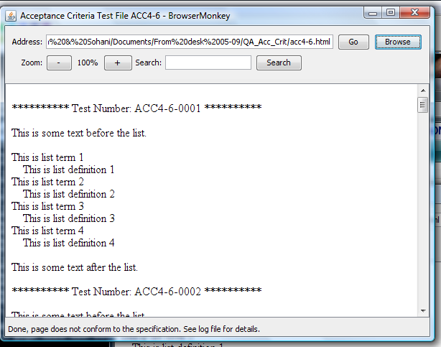

## Blockquote

|  |  |  |  |  |
| --- | --- | --- | --- | --- |
| **Test id** | **Tested by** | **Most recent test** | **Pass/fail** | **Details** |
| acc4-7-0001 | Sohani Amiruzzaman | 05/06/2009 | pass |  |
| acc4-7-0002 | Sohani Amiruzzaman | 05/06/2009 | pass |  |
| acc4-7-0003 | Sohani Amiruzzaman | 05/06/2009 | pass |  |
| acc4-7-0004 | Sohani Amiruzzaman | 05/06/2009 | pass |  |
| acc4-7-0005 | Sohani Amiruzzaman | 05/06/2009 | pass |  |
| acc4-7-0006 | Sohani Amiruzzaman | 05/06/2009 | pass |  |
| acc4-7-0007 | Sohani Amiruzzaman | 05/06/2009 | pass |  |
| acc4-7-0008 | Sohani Amiruzzaman | 05/06/2009 | pass |  |

Screenshot

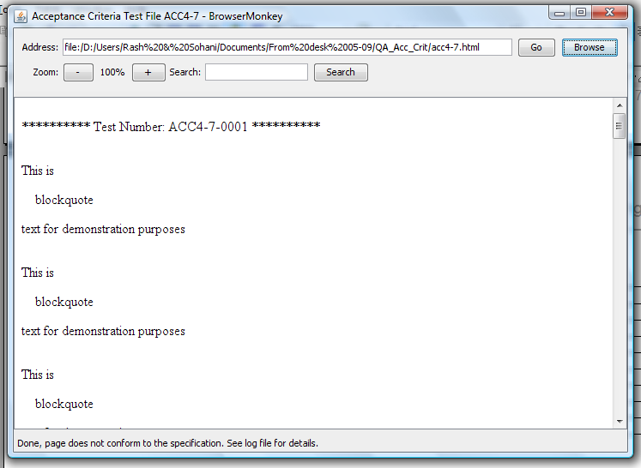

## Centred Text

.

|  |  |  |  |  |
| --- | --- | --- | --- | --- |
| **Tests Id** | **Tested by** | **Most Recent Test** | **Pass/Fail** | **Details** |
| acc4-8-0001 | Elpida Kyriakou | 05/06/2009 | Pass |  |
| acc4-8-0002 | Elpida Kyriakou | 05/06/2009 | Pass |  |
| acc4-8-0003 | Elpida Kyriakou | 05/06/2009 | Pass |  |
| acc4-8-0004 | Elpida Kyriakou | 05/06/2009 | Pass |  |
| acc4-8-0005 | Elpida Kyriakou | 05/06/2009 | Pass |  |
| acc4-8-0006 | Elpida Kyriakou | 05/06/2009 | Pass |  |
| acc4-8-0007 | Elpida Kyriakou | 05/06/2009 | Pass |  |
| acc4-8-0008 | Elpida Kyriakou | 05/06/2009 | Pass |  |

Screenshot

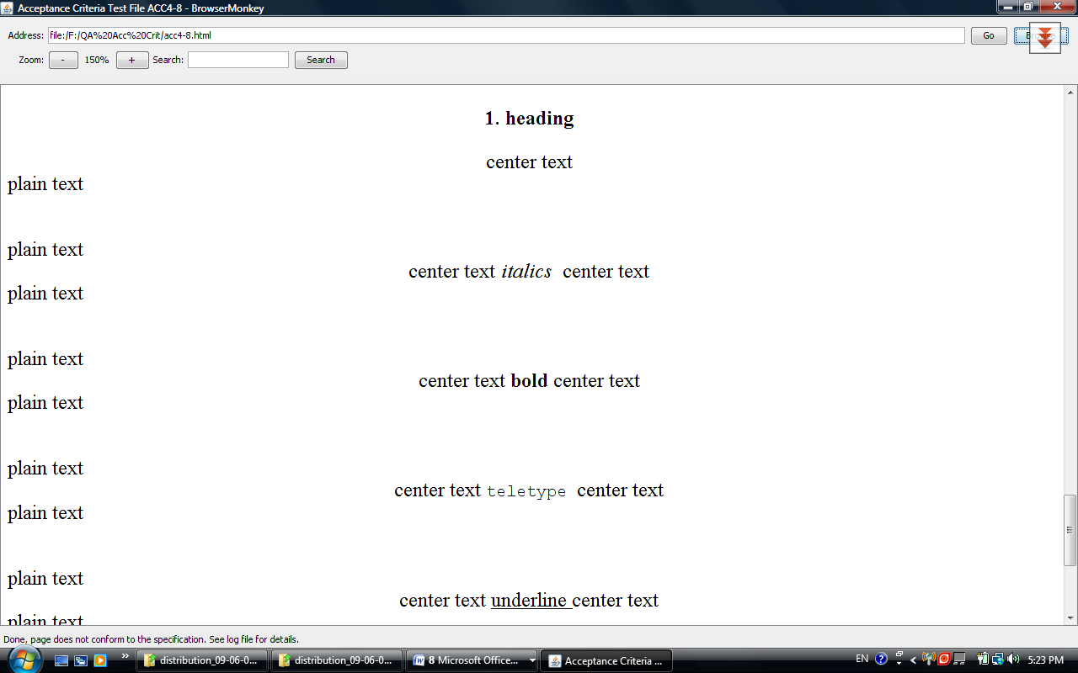

## Pre-formatted Text

|  |  |  |  |  |
| --- | --- | --- | --- | --- |
| **Tests Id** | **Tested by** | **Most Recent Test** | **Pass/Fail** | **Details** |
| acc4-9-0001 | Elpida Kyriakou | 05/06/2009 | Pass |  |
| acc4-9-0002 | Elpida Kyriakou | 05/06/2009 | Pass |  |
| acc4-9-0003 | Elpida Kyriakou | 05/06/2009 | Pass |  |
| acc4-9-0004 | Elpida Kyriakou | 05/06/2009 | Pass |  |
| acc4-9-0005 | Elpida Kyriakou | 05/06/2009 | Pass |  |
| acc4-9-0006 | Elpida Kyriakou | 05/06/2009 | Pass |  |
| acc4-9-0007 | Elpida Kyriakou | 05/06/2009 | Pass |  |
| acc4-9-0008 | Elpida Kyriakou | 05/06/2009 | Pass |  |

Screenshot

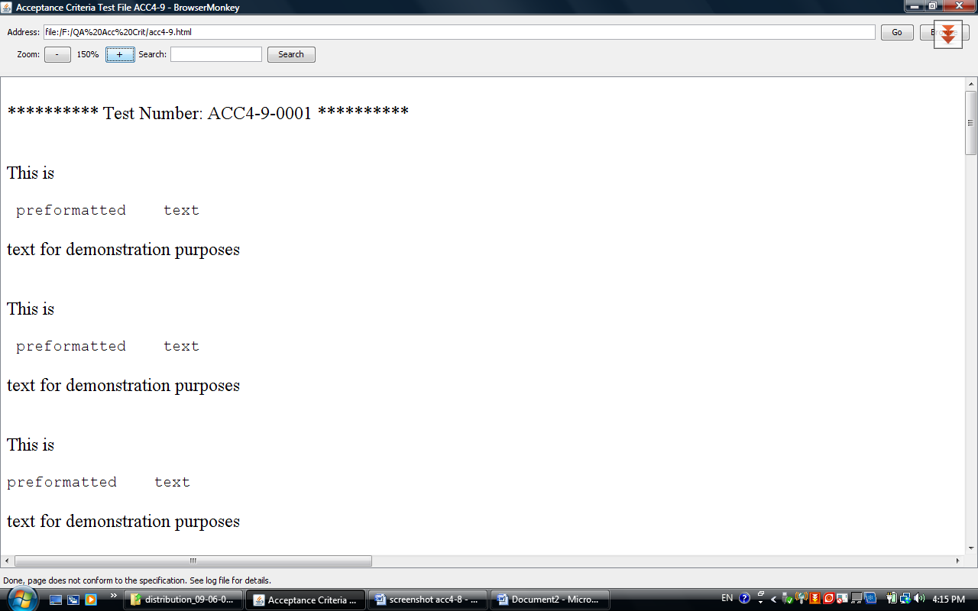

## Horizontal Rule

|  |  |  |  |  |
| --- | --- | --- | --- | --- |
| **Tests Id** | **Tested by** | **Most Recent Test** | **Pass/Fail** | **Details** |
| acc4-10-0001 | Elpida Kyriakou | 05/06/2009 | Pass |  |
| acc4-10-0002 | Elpida Kyriakou | 05/06/2009 | Pass |  |
| acc4-10-0003 | Elpida Kyriakou | 05/06/2009 | Pass |  |
| acc4-10-0004 | Elpida Kyriakou | 05/06/2009 | Pass |  |

Screenshot

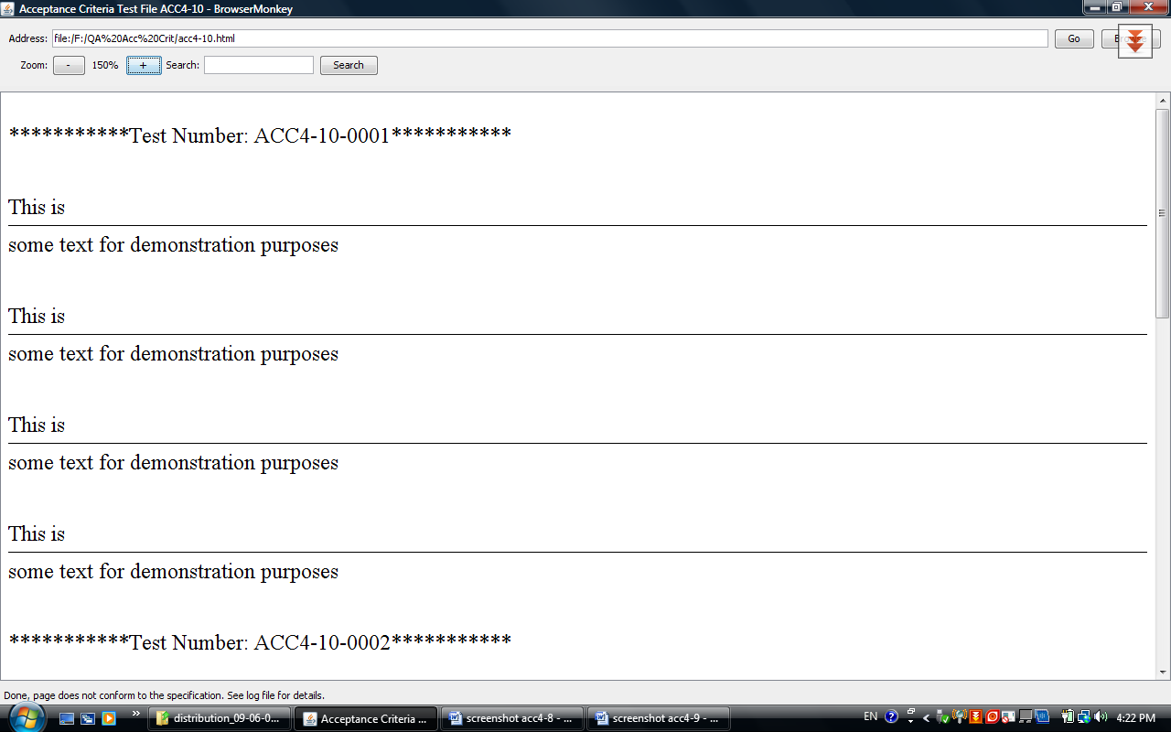

## Italics

Tested passed

|  |  |  |  |  |
| --- | --- | --- | --- | --- |
| **Tests Id** | **Tested by** | **Most Recent Test** | **Pass/Fail** | **Details** |
| acc4-11-0001 | Elpida Kyriakou | 05/06/2009 | Pass |  |
| acc4-11-0002 | Elpida Kyriakou | 05/06/2009 | Pass |  |
| acc4-11-0003 | Elpida Kyriakou | 05/06/2009 | Pass |  |
| acc4-11-0004 | Elpida Kyriakou | 05/06/2009 | Pass |  |
| acc4-11-0005 | Elpida Kyriakou | 05/06/2009 | Pass |  |
| acc4-11-0006 | Elpida Kyriakou | 05/06/2009 | Pass |  |
| acc4-11-0007 | Elpida Kyriakou | 05/06/2009 | Pass |  |
| acc4-11-0008 | Elpida Kyriakou | 05/06/2009 | Pass |  |

Screenshot

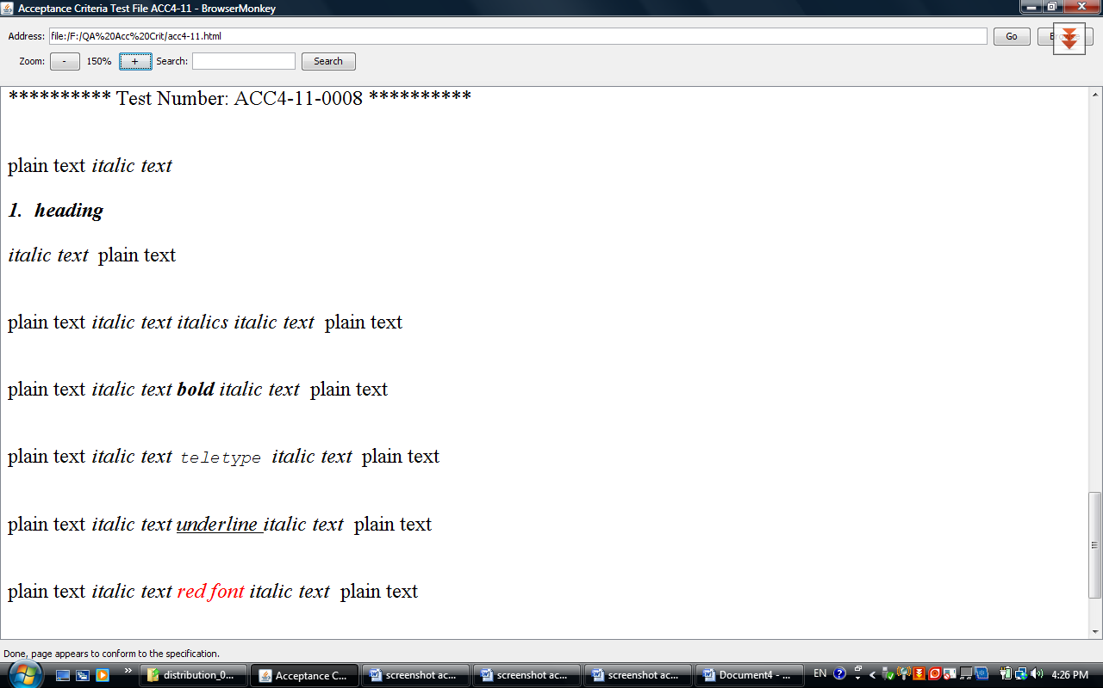

## Bold

|  |  |  |  |  |
| --- | --- | --- | --- | --- |
| **Tests Id** | **Tested by** | **Most Recent Test** | **Pass/Fail** | **Details** |
| acc4-12-0001 | Elpida Kyriakou | 05/06/2009 | Pass |  |
| acc4-12-0002 | Elpida Kyriakou | 05/06/2009 | Pass |  |
| acc4-12-0003 | Elpida Kyriakou | 05/06/2009 | Pass |  |
| acc4-12-0004 | Elpida Kyriakou | 05/06/2009 | Pass |  |
| acc4-12-0005 | Elpida Kyriakou | 05/06/2009 | Pass |  |
| acc4-12-0006 | Elpida Kyriakou | 05/06/2009 | Pass |  |
| acc4-12-0007 | Elpida Kyriakou | 05/06/2009 | Pass |  |
| acc4-12-0008 | Elpida Kyriakou | 05/06/2009 | Pass |  |

Screenshot

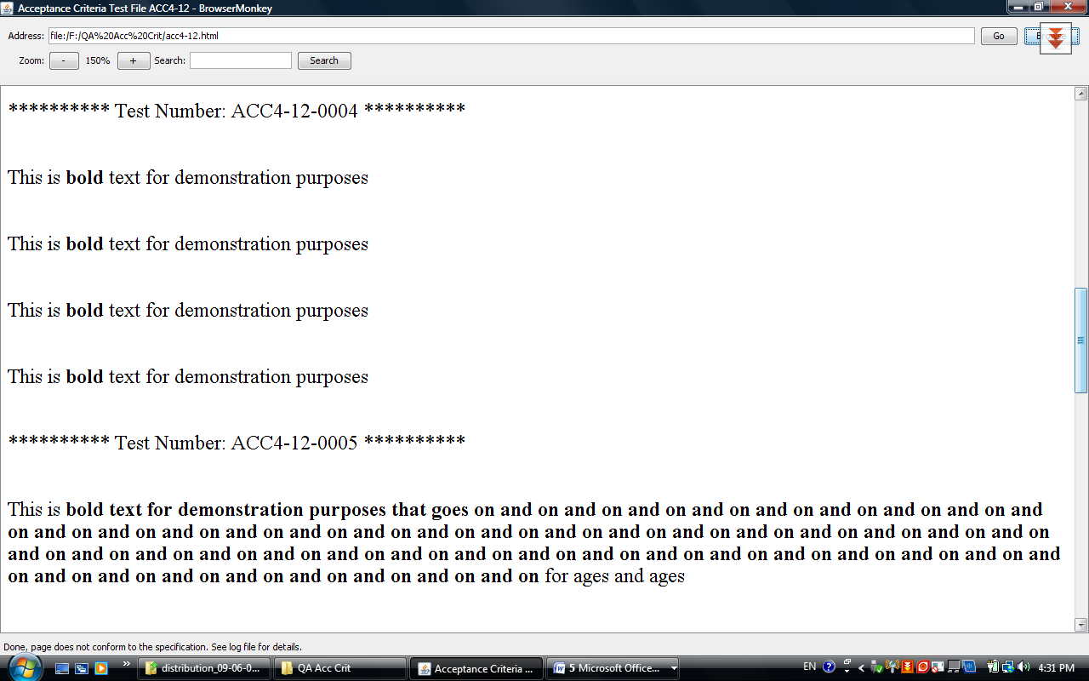

## Teletype

|  |  |  |  |  |
| --- | --- | --- | --- | --- |
| **Tests Id** | **Tested by** | **Most Recent Test** | **Pass/Fail** | **Details** |
| acc4-13-0001 | Elpida Kyriakou | 05/06/2009 | Pass |  |
| acc4-13-0002 | Elpida Kyriakou | 05/06/2009 | Pass |  |
| acc4-13-0003 | Elpida Kyriakou | 05/06/2009 | Pass |  |
| acc4-13-0004 | Elpida Kyriakou | 05/06/2009 | Pass |  |
| acc4-13-0005 | Elpida Kyriakou | 05/06/2009 | Pass |  |
| acc4-13-0006 | Elpida Kyriakou | 05/06/2009 | Pass |  |
| acc4-13-0007 | Elpida Kyriakou | 05/06/2009 | Pass |  |
| acc4-13-0008 | Elpida Kyriakou | 05/06/2009 | Pass |  |

Screenshot

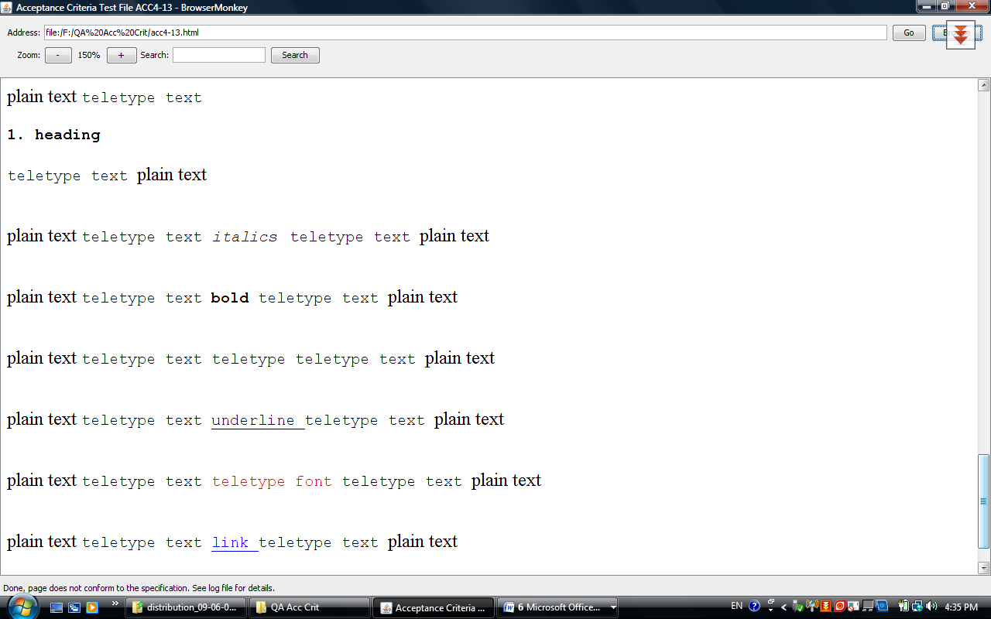

## Underline

|  |  |  |  |  |
| --- | --- | --- | --- | --- |
| **Tests Id** | **Tested by** | **Most Recent Test** | **Pass/Fail** | **Details** |
| acc4-14-0001 | Elpida Kyriakou | 05/06/2009 | Pass |  |
| acc4-14-0002 | Elpida Kyriakou | 05/06/2009 | Pass |  |
| acc4-14-0003 | Elpida Kyriakou | 05/06/2009 | Pass |  |
| acc4-14-0004 | Elpida Kyriakou | 05/06/2009 | Pass |  |
| acc4-14-0005 | Elpida Kyriakou | 05/06/2009 | Pass |  |
| acc4-14-0006 | Elpida Kyriakou | 05/06/2009 | Pass |  |
| acc4-14-0007 | Elpida Kyriakou | 05/06/2009 | Pass |  |
| acc4-14-0008 | Elpida Kyriakou | 05/06/2009 | Pass |  |

Screenshot

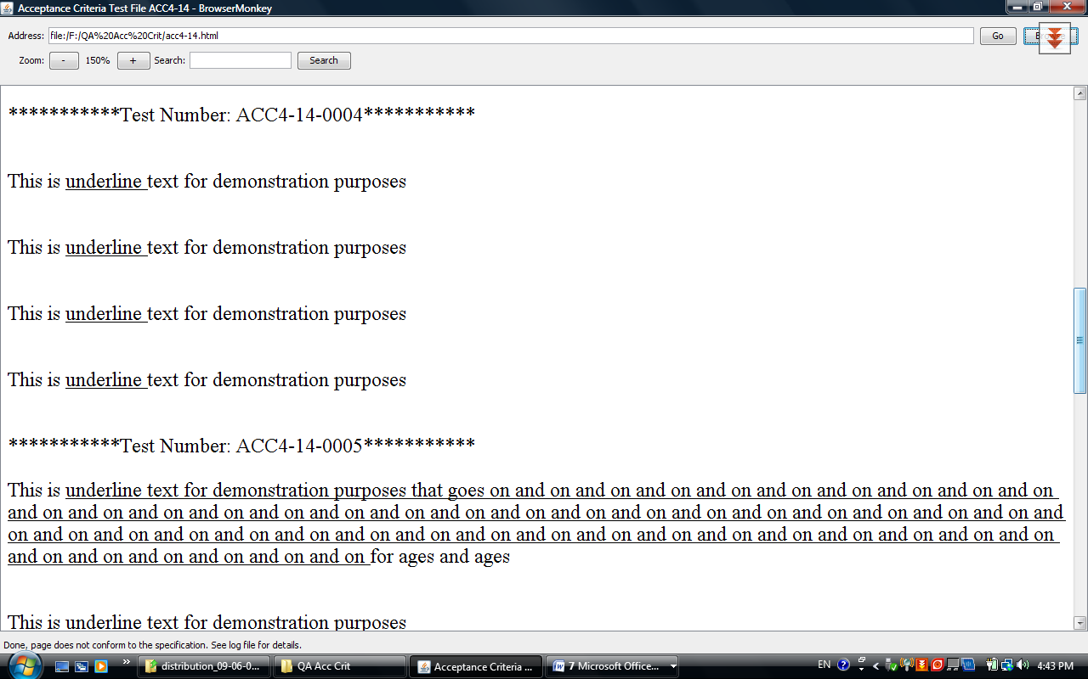

## Font

|  |  |  |  |  |
| --- | --- | --- | --- | --- |
| **Tests Id** | **Tested by** | **Most Recent Test** | **Pass/Fail** | **Details** |
| acc4-15-0001 | Elpida Kyriakou | 05/06/2009 | Pass |  |
| acc4-15-0002 | Elpida Kyriakou | 05/06/2009 | Fail | The word “red” it should be red in all sentences. |
| acc4-15-0003 | Elpida Kyriakou | 05/06/2009 | Pass |  |
| acc4-15-0004 | Elpida Kyriakou | 05/06/2009 | Fail | Only the word red should be red in the third sentence. |
| acc4-15-0005 | Elpida Kyriakou | 05/06/2009 | Pass |  |
| acc4-15-0006 | Elpida Kyriakou | 05/06/2009 | Pass |  |
| acc4-15-0007 | Elpida Kyriakou | 05/06/2009 | Pass |  |
| acc4-15-0008 | Elpida Kyriakou | 05/06/2009 | Pass |  |
| acc4-15-0009 | Elpida Kyriakou | 05/06/2009 | Pass |  |
| acc4-15-0010 | Elpida Kyriakou | 05/06/2009 | Pass |  |
| acc4-15-0011 | Elpida Kyriakou | 05/06/2009 | Pass |  |
| acc4-15-0012 | Elpida Kyriakou | 05/06/2009 | Pass |  |
| acc4-15-0013 | Elpida Kyriakou | 05/06/2009 | Pass |  |
| acc4-15-0014 | Elpida Kyriakou | 05/06/2009 | Pass |  |
| acc4-15-0015 | Elpida Kyriakou | 05/06/2009 | Pass |  |
| acc4-15-0016 | Elpida Kyriakou | 05/06/2009 | Pass |  |

*Programming Notes:*

The acceptance criteria was non-standard here, allowing colours to be specified as color=FF0000 for example (omitting the #), we decided not to support this type of attribute.

Screenshot

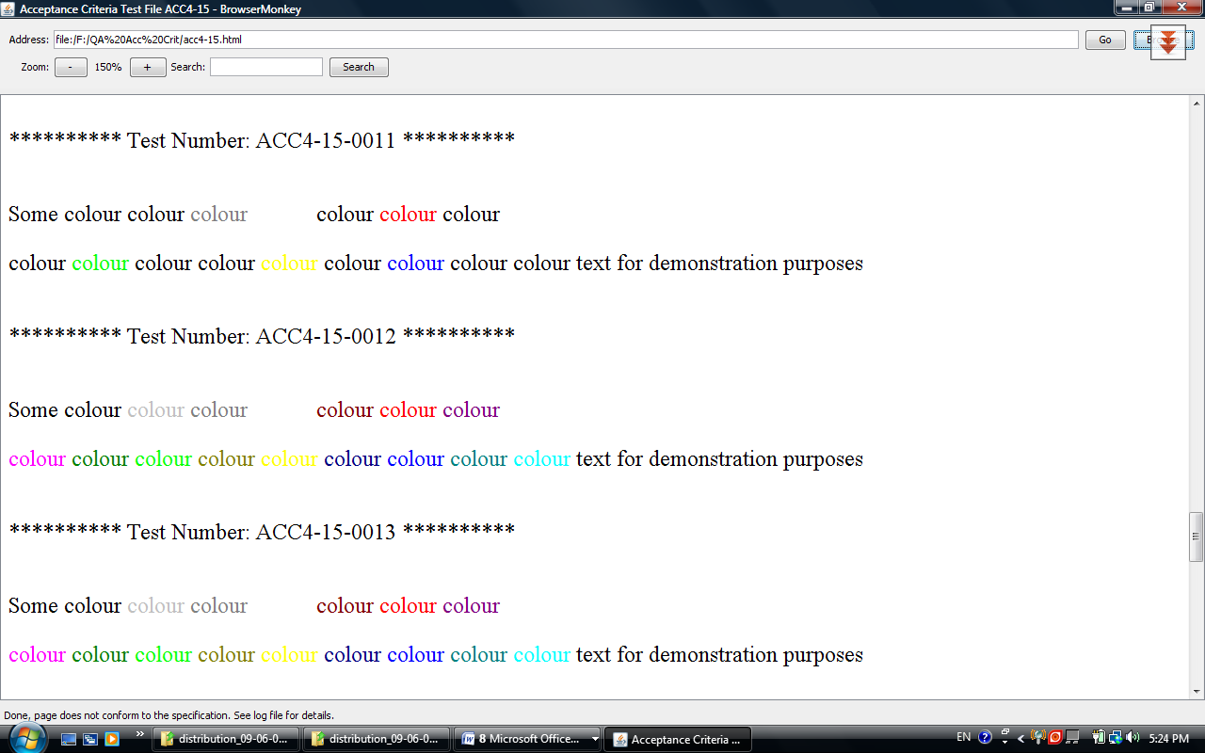

# Requirements 5 – Tables

|  |  |  |  |  |
| --- | --- | --- | --- | --- |
| **Tests Id** | **Tested by** | **Most Recent Test** | **Pass/Fail** | **Details** |
| acc5-0001 | Sohani Amiruzzaman | 5/06/2009 | Pass |  |
| acc5-0002 | Sohani Amiruzzaman | 5/06/2009 | Pass |  |
| acc5-0003 | Sohani Amiruzzaman | 5/06/2009 | Pass |  |
| acc5-0004 | Sohani Amiruzzaman | 5/06/2009 | Fail |  |
| acc5-0005 | Sohani Amiruzzaman | 5/06/2009 | Pass |  |
| acc5-0006 | Sohani Amiruzzaman | 5/06/2009 | Fail |  |
| acc5-0007 | Sohani Amiruzzaman | 5/06/2009 | Pass |  |
| acc5-0008 | Sohani Amiruzzaman | 5/06/2009 | Pass |  |
| acc5-0009 | Sohani Amiruzzaman | 5/06/2009 | Pass |  |
| acc5-0010 | Sohani Amiruzzaman | 5/06/2009 | Pass |  |

*Programming Notes:*

The two fails above are a result of incorrect mark-up in the test itself, the table functionality does work fully.

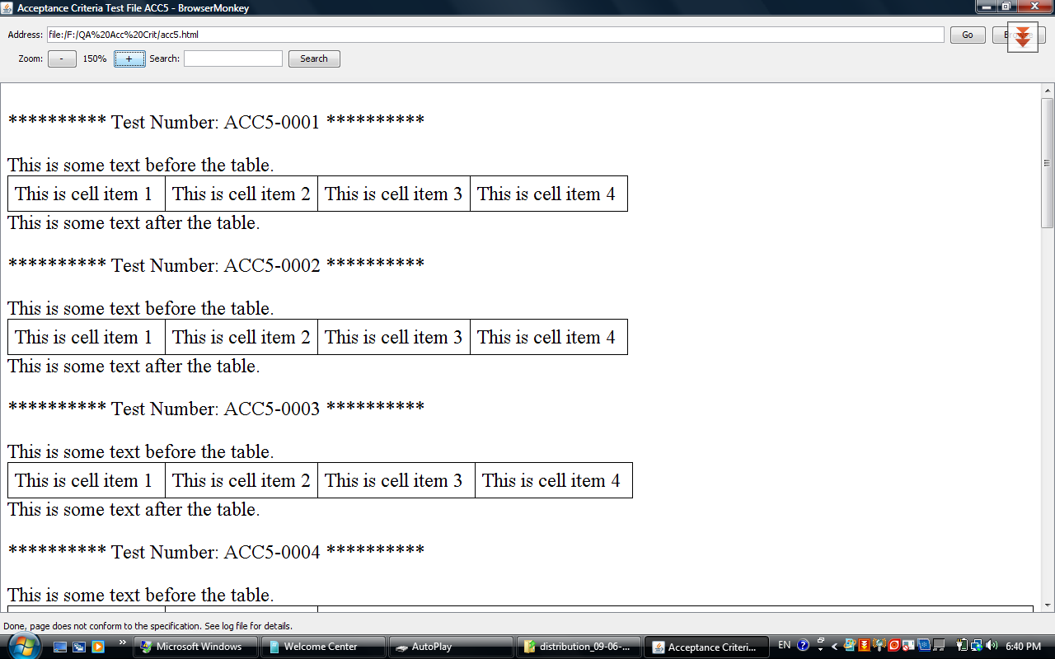

# Requirement 6 – Links

|  |  |  |  |  |
| --- | --- | --- | --- | --- |
| **Tests Id** | **Tested by** | **Most Recent Test** | **Pass/Fail** | **Details** |
| acc6-0001 | Irene Schiza | 05/06/2009 | Pass |  |
| acc6-0002 | Irene Schiza | 05/06/2009 | Fail |  |
| acc6-0003 | Irene Schiza | 05/06/2009 | Pass |  |
| acc6-0004 | Irene Schiza | 05/06/2009 | Pass |  |
| acc6-0005 | Irene Schiza | 05/06/2009 | Pass |  |
| acc6-0006 | Irene Schiza | 05/06/2009 | Pass |  |
| acc6-0007 | Irene Schiza | 05/06/2009 | Pass |  |
| acc6-0008 | Irene Schiza | 05/06/2009 | Pass |  |

*Programming Notes:*

The fail above is again a result of incorrect mark-up in the test itself, causing the link to span across a space before and after it. The link functionality does work fully.

Screenshot

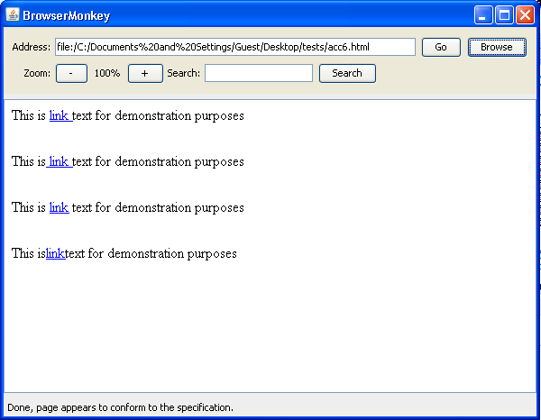

# Requirement 7 – Search

|  |  |  |  |  |
| --- | --- | --- | --- | --- |
| **Tests Id** | **Tested by** | **Most Recent Test** | **Pass/Fail** | **Details** |
| acc7-0001 | Ioanna Kyprianou | 05/06/2009 | Pass |  |
| acc7-0002 | Ioanna Kyprianou | 05/06/2009 | Pass |  |
| acc7-0003 | Ioanna Kyprianou | 05/06/2009 | Pass |  |
| acc7-0004 | Ioanna Kyprianou | 05/06/2009 | Pass |  |
| acc7-0005 | Ioanna Kyprianou | 05/06/2009 | Pass |  |
| acc7-0006 | Ioanna Kyprianou | 05/06/2009 | Pass |  |
| acc7-0007 | Ioanna Kyprianou | 05/06/2009 | Pass |  |
| acc7-0008 | Ioanna Kyprianou | 05/06/2009 | Pass |  |
| acc7-0009 | Ioanna Kyprianou | 05/06/2009 | Pass |  |
| acc7-00010 | Ioanna Kyprianou | 05/06/2009 | Pass |  |

Screen shots:

ACC7-0004

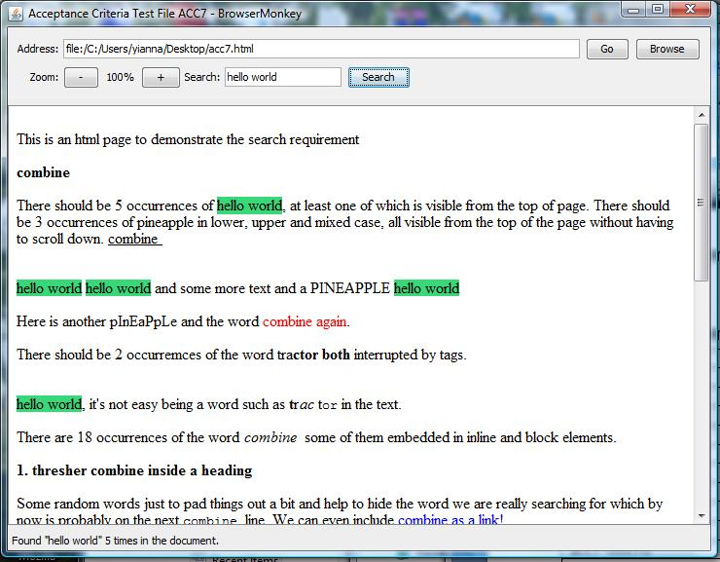

ACC7-0009

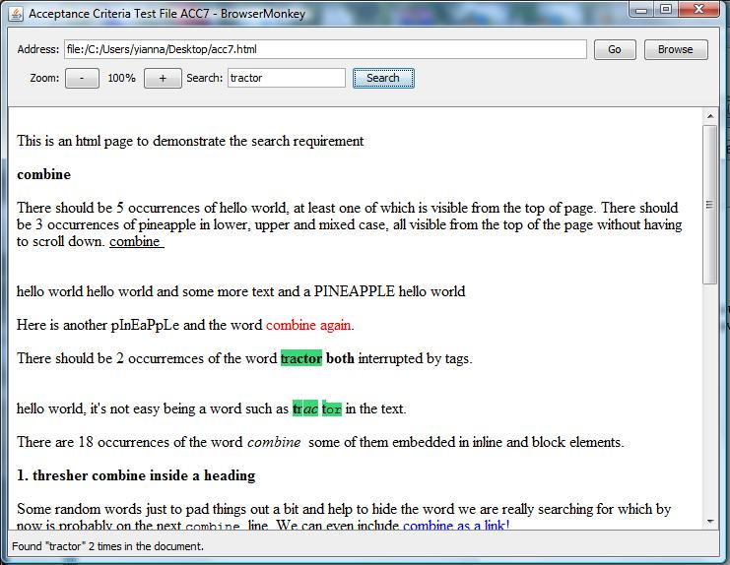

# Requirement 8 – Zoom

|  |  |  |  |  |
| --- | --- | --- | --- | --- |
| **Tests Id** | **Tested by** | **Most Recent Test** | **Pass/Fail** | **Details** |
| acc4-14-0001 | Elpida Kyriakou | 05/06/2009 | Pass |  |
| acc4-14-0002 | Elpida Kyriakou | 05/06/2009 | Pass |  |
| acc4-14-0003 | Elpida Kyriakou | 05/06/2009 | Pass |  |
| acc4-14-0004 | Elpida Kyriakou | 05/06/2009 | Pass |  |
| acc4-14-0005 | Elpida Kyriakou | 05/06/2009 | Pass |  |
| acc4-14-0006 | Elpida Kyriakou | 05/06/2009 | Pass |  |
| acc4-14-0007 | Elpida Kyriakou | 05/06/2009 | Pass |  |
| acc4-14-0008 | Elpida Kyriakou | 05/06/2009 | Pass |  |

In addition to the simple tests outlined above. An additional few tests were added to test zooming of complicated structured files, and images. These were aspects of zoom that were not originally intended to be in the application.

We used a complicated html file that is actually the customer requirements document for this project.

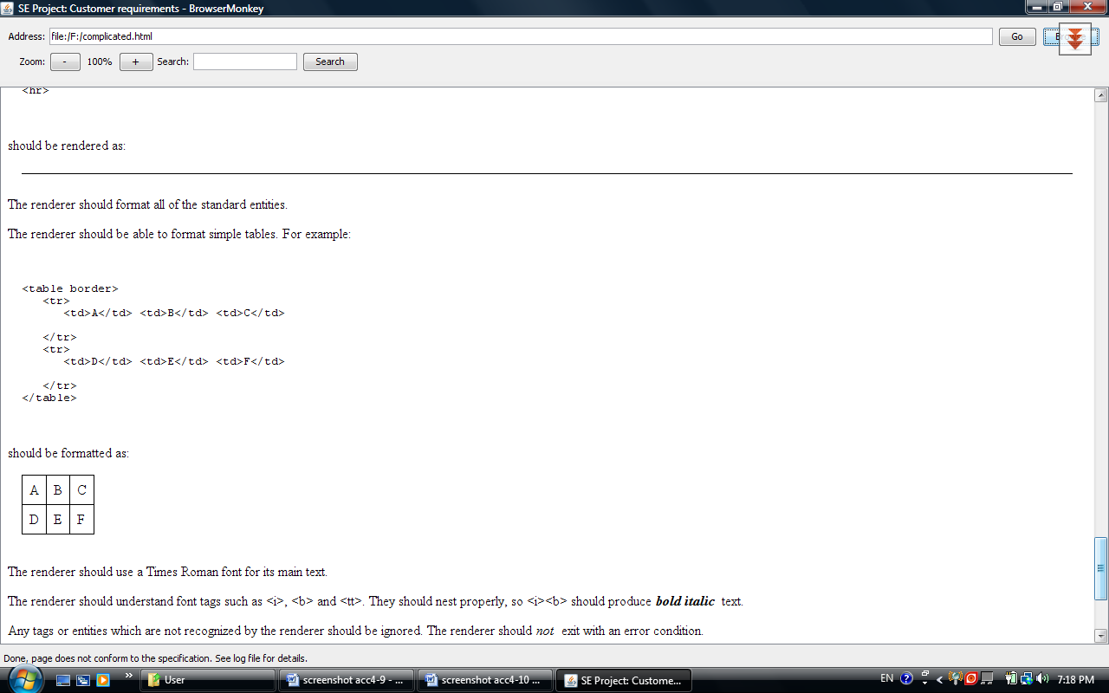

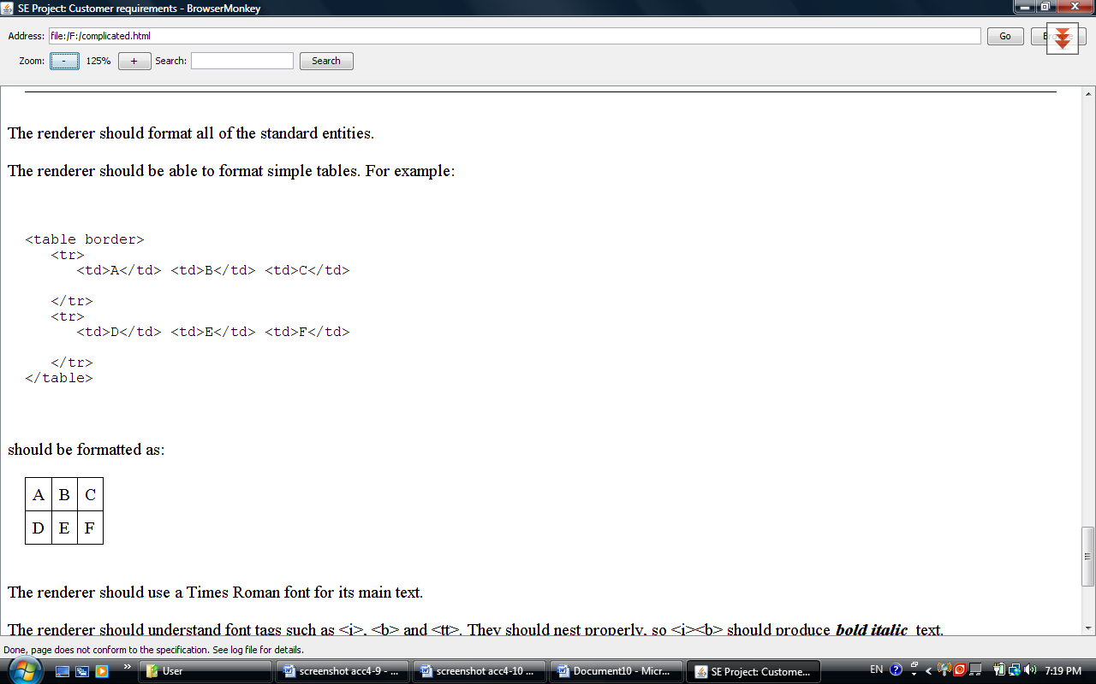

This shows pre tags, tables etc, zooming correctly.

To test image zooming, we will use the main page:

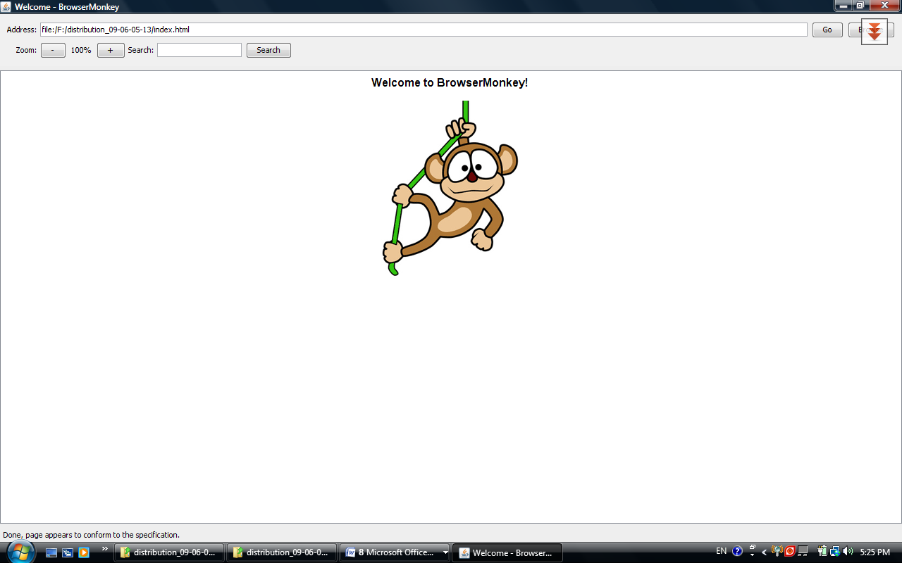

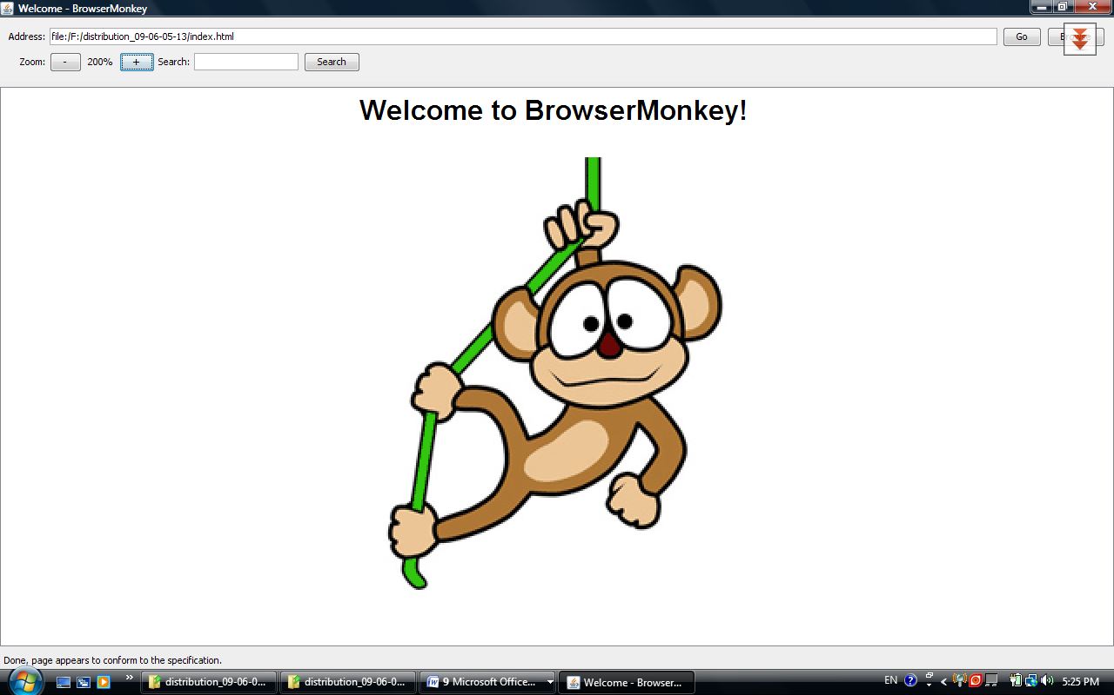

Image and text zooms correctly.